31/10/2019

**Task:**

* Install ESP8266 SDK
* Get Blink from examples running
* Test WIFI example
* Bring ADLX357 firmware from Analog Devices into project

**Reflection:**

Decided to use esp8266 native SDK as development kit and implemented the communication with adlx357 accelerometer via SPI.

I tested 3 options available.

* Install Virtual Studio Code and add the plugin for PlatformIO(PIO)
* Install through CLI command in Linux VirtualBox
* Install Eclipse and setup SDK

I downloaded the toolchain from espressif ESP8266_RTOS_SDK

git clone --recursive https://github.com/espressif/ESP8266_RTOS_SDK.git

Installed the packages gcc git wget make libncurses-dev flex bison gperf python python-serial

Created the repo and extracted the toolchain xtensa-lx106-elf and concatenated to PATH environment variable in ~./profile to make available for all terminal sessions



Installed the Python packages require





Set environment variable and define permanently in profile





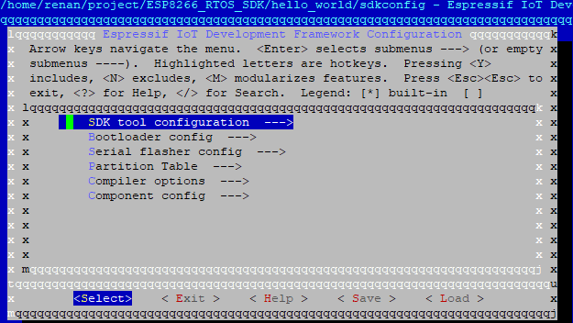

Even spending three days to setup the environment it was a great opportunity to review Linux commands and learn how to run and compile using executable binary files using Make.

Eclipse IDE didn’t work as I expected but found easy to use VSC (Visual Studio Code) IDE to edit the code.

To flash into MCU I will use make command.

Next step is adapting driver from old adlx355 and restructure for adlx357 MEM.

**Issues:**

* + Deliverables are delayed need to expend extra time to catch up gap from last two weeks
  + Could not install SDK in Windows OS

**Solution:**

* Installed SDK in Ubuntu Virtual Machine using a oracle VirtualBox and flash board using makeFiles.

References:

<https://docs.espressif.com/projects/esp8266-rtos-sdk/en/latest/get-started/index.html#get-started-get-esp-idf>

<https://docs.espressif.com/projects/esp8266-rtos-sdk/en/latest/get-started/eclipse-setup-windows.html#eclipse-windows-setup>

<https://github.com/espressif/ESP8266_RTOS_SDK/tree/release/v3.2>

# <https://www.youtube.com/watch?v=T-oSjMCmNYk> - AMMAURO #3 - ESP8266 IoT 2017, native C SDK Getting Started for Windows, Mac & Linux

<https://blog.podkalicki.com/esp8266-building-the-toolchain-for-linux-ubuntu/>

<https://blog.podkalicki.com/installing-esp8266-rtos-sdk-on-linux/>

<https://www.espressif.com/sites/default/files/documentation/2a-esp8266-sdk_getting_started_guide_en.pdf>

<https://exploreembedded.com/wiki/Setting_up_Eclipse_for_ESP-IDF>

<https://www.embarcados.com.br/programando-esp8266-em-c-no-eclipse/>

https://github.com/analogdevicesinc/EVAL-ADICUP360/tree/master/projects/ADuCM360_demo_adxl355_pmdz

https://jonnylangefeld.github.io/learning/Docker/How%2Bto%2BDocker.html